From
Christer Liden, ComActivity Pty Ltd
+61 416 08 64 23
Christer.Liden@comactivity.net

29/1/2008

To
Robert Gold

Startronics  Unit 47,  Slough Business Estate,  Slough Avenue  Silverwater NSW 2128  Australia |  | Commercial in Confidence  This document is submitted to Startronics Pty. Ltd. in Confidence. No part of this document or the information within it shall be shown or provided to any other party without prior written approval from Comactivity. Permission is granted for the copying of all or part of this document for internal distribution and evaluation, provided always that this notice is included in every copy and that this notice should apply to all copies.
Version | 1.0
Release Date | 19-01-2008
Reviewed By | Torben Magnusson, ComActivity Pty Ltd
Owner of Document | Christer Liden, ComActivity Pty Ltd
Project Identity | ComActivity and Startronics
Name of File | 0000.doc
© 2008 ComActivity Pty Ltd
Level 1, Building 2
49 Frenchs Forest Road
Frenchs Forest
NSW 2086
Phone: +61 2 9479 7949
www.comactivity.net

Table of Contents
1 Introduction 2
2 Background 2
3 Project Scope 3
3.1 Creation of header record 3
3.2 Creation of the line record for new item (part or product) 5
3.3 Creation of the line record for change of item (part or product) 8
3.4 Creation of the line record for change of BoM 10
3.5 Creation of the line record for authorizers of ECN 12
3.6 Work flow 13
4 ComActivity Project Team 14
5 System Requirements 14

Introduction
This specification has been prepared at the request of Robert Gold Startronics Pty Ltd. The document details ComActivity’s proposal to create a solution for creating and or changing items / product and or BoM within Movex.

Background
Startronics is currently implementing Movex V12 planned for go live end of Feb. Movex is to replace the existing Oracle implementation. Startonics Perth is also currently using a separate solution for maintaining basic data such as BoM Products and Items. Whilst the basic data module of Movex provides the basic functionality required by the engineering and document team, it lacks the required functionality. This document outlines a solution the will meet the required functionality.

There are mainly four separate functions required
- Create a new part, new MPN, product (bom), Routing (routing to be done after go-life) (this would in Movex relate to MMS001 (Item master file), MMS002 (Item Warehouse file) and MMS003 (Item Facility file).
- To change a part (eg. Status, Description, etc) (this would in Movex relate to MMS001 (Item master file, MITMAS), MMS002 (Item Warehouse file, MITBAL) and MMS003 (Item Facility file, MITFAC) and change the MPN.
- To change or create the BOM and Routing (to be done after go live) on an existing product (this would relate to PDS001 MPDHED and PDS002 MPDMAT)
- The forth is to create and maintain supporting documentation. This solution is based on the assumption that all document management will be handled through Microsoft SharePoint solution. This is a web based document management solution and even though the documents as such are held and managed inside SharePoint, though this customer folder can be reached via a link from the ComActivity solution. However, documents and DMR must be part of Movex BOM and change initiation (creation of the ECN) should be included is via ComActivity solution.

The principle goal of this project is to provide control and structure for the process of setting up and maintaining basic data. Some of Startronics customers require strict control of basic data from a quality aspect.

Features included in this solution.
There are many advantages with this solution and there will be a number of features implemented as part of this solution

- Security – User security can be defined by user or user group and can be defined to menu option, fields (view, change, not displayed), field records (one customer would only be able to view their own records
- Audit trail – Field is can be tagged for audit trail whereby each change is logged and can be displayed
- Workflow enabled
  - The workflow is configured graphically
  - Can run parallel flows
  - Can trigger escalations, alarms and notifications
  - Can generate SMS, e-mail and on screen work items
  - Can be triggered with due dates and
  - Work flow statistics
- Generic Search capabilities in list views
- Electronic signature can be implemented
- Part of Movex gives us full control, data validation and integrity
- Generic import and export to and from Excel

Project Scope
The preliminary project scope, as understood by ComActivity, is based on the document Agile Movex Interface V1 . This document that was created as an output of the meeting held on Wednesday 16th Jan 2008 at Startronics’s Perth Operation

The process can be described in the following steps.

- Someone (Customer or someone in Engineering raises an ECN).
An ECN will consist of header information and a number of detailed records (new item (part of product) creation, change item and change of BoM)
- Once the ECN has been completed it is moved (workflow driven) to the document department who verifies the information. If the document person does not approve the request goes back to the engineers.
- Once the ECN has been approved it will need a final approval from a list of managers.
- Once the final approval has been received the document manager will implement the change. The implementation will take step by step. I.e. the creation of new items must take place first and then the change of item then the change of routing and last the change of BoM. The implementation will generate different statuses for each step.

Also there is a built-in export – import to Excel functionality. In other words each list view can be either or imported or exported to and from Excel.

Creation of header record

The user (generally a customer or one of the engineers will log on to the application and select menu option ECN. By clicking on this option a list of ECN will appear on the screen.

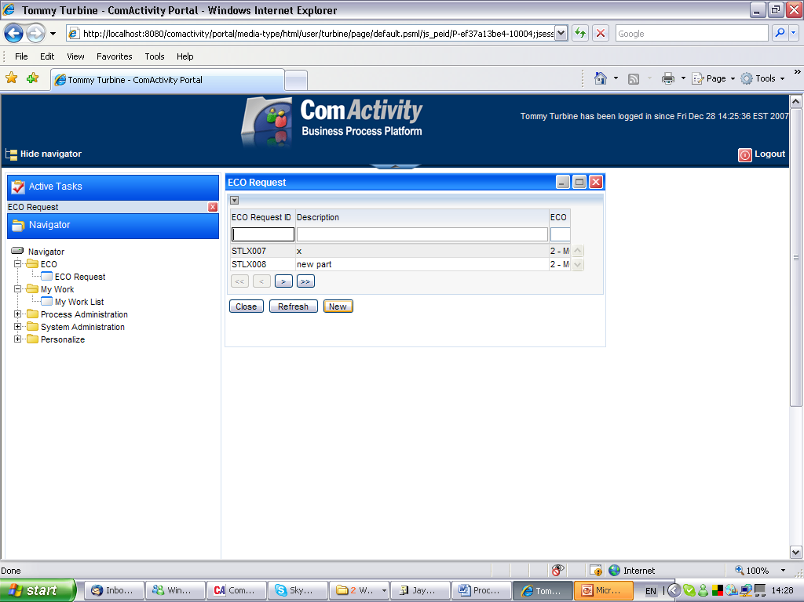

Each ECN will have a status that indicates where the ECN is in the flow.
Name | Value | Description
Preliminary | 10 | Just created but not completed
Pending Logistic Review | 20 | Pending to be reviewed by logistician
Pending Document Controller Review | 30 | Pending to be reviewed by the document controller
Pending Approval | 40 | All approvers have approved the changes
Pending Final Approval | 50 | Pending to be approved by the document controller
Pending Costing | 60 | Pending to set the costing for the ECN
Pending Release | 70 | Pending to be released.
Implemented | 80 | Implemented
Closed | 90 | ECN closed

To create a new ECN the user would click on the button “Create New”. A detailed Screen would appear where the user would enter the following information. An internal ECN number would be generated automatically that will give the ECN a unique ID.

For this we need to create a new number series in CSYNBR or CRS165. The number series type (CNNBTY in CSYNBR) will be E1 and the number series will be 1 (CNNBID in CSYNBR). These records can be maintained from CRS165 under blank division.

The name of this table will be ZECNHEAD and the field prefix would be EH

Name | Description | Logic | Size | Movex
Company Number |  | Picked from the sitedef | 3 N | CONO
ECN number | Internal ECN number. This is a new field | This is automatically generated | 5 N | ZECNID
ECN Status | Status of the ECN | There will be a number of different statuses (see above). It will be possible to add or change different status. Default status should be “Preliminary” | 15 A | ZECNST
Requestor | The user that requests the ECN | Defaults to the user that created the ECN but this value maybe changed. The value is validated against the list of Movex users. Default from the user raising the request | 10A | RESP
Date | Date when the ECN was raised | Defaults to today’s date | 8 N | RGDT
Effective Date | Date when the changes are to be implemented. This is only applicable for BoM changes. | Defaults to today’s date but this can be changed. This value will be the default value to be used on BoM lines | 8 N | FDAT
ECN type | This would indicate the type of ECN. | ECO (BOM), MCO (ITEM). These values would be pre defined values. This will be predefined list. | 3 A | ZECNTP
Customer Number | The Customer number in Movex, OCUSMA, OKCUNO | To be validated against Movex | 15 A | CUNO
Customer ECR | The Customer’s ECR number | To be keyed in if required. No validation | 20 A | ZECNRF
Product number | The product number that would be affected | To be keyed in if required, will be validated against the item master file(MITMAS) if entered. Not a required field | 15A | PRNO
ECN Description | This is a description of the ECN. The value in this field is information only and will not be transferred to the product or item within Movex. This test is only related to the ECN itself. | This is a free text and the format is a text clob and as such there is no limit to the length of the text. | Text clob | ZECNTX
New Parts Required | Flag to indicate that there are number parts required to be set up as part of this ECN | This is only a flag and the value can be either 0 or 1. This is information only | 1 N | ZNEWPR
Change Parts Required | Flag to indicate that there are number parts required to be set up | This is only a flag and the value can be either 0 or 1  This is information only | 1 N | ZCHGPR
Change BOM's Required | Flag to indicate that there is a BoM that needs to be changed. | This is only a flag and the value can be either 0 or 1 | 1 N | ZCHGBR
Change routing Required | Flag to indicate that there is a routing that needs to be changed. | This is only a flag and the value can be either 0 or 1 | 1 N | ZCHGRR
Change to Documents | Flag to indicate that there are documents that would need to be changed. | This is only a flag and the value can be either 0 or 1 | 1 N | ZCHGDC
Document Changes Description | This is a description of the document changes ECN. | This is a free text and the format is a text clob and as such there is no limit to the length of the text. | Text clob | ZCHGTX
We will also include the sections 6 from the current form in the header (see below)

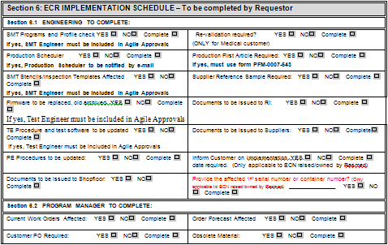

Section 5: NON-RECURRING COSTS OF IMPLEMENTATION – to be completed by Engineering and Program Manager
NOTE: FOR AML ADDITIONS ONLY, SECTION 5 AND 6.2 ARE NOT REQUIRED TO BE FILLED IN BY PROGRAM MANAGER
Sec 5.A: NON-RECURRING ENGINEERING COSTS (cost of rework, stencils, tooling, engineering setup etc)
Cost prepared by (Engineer): ______________________
Engineering Manager Approval: _________________________  (required if Non-recurring or on-going engineering costs involved) |  | TOTAL NON-RECURRING COSTS: | $______________
Sec 5.B: NON-RECURRING MATERIAL COSTS (cost of material obsolescence, supplier tooling/ set-up, samples for FAI etc)
Cost prepared by (Program Manager): _______________________ | TOTAL NON-RECURRING MATERIAL COSTS: |  | $_______________
Sec 5.C: TOTAL NON-RECURRING COSTS = (A) + (B) = ENGINEERING COSTS + MATERIAL COSTS |  |  |  | $
Sec 5.D: Change to Ongoing Unit Material and Labour Costs = (D) + material unit price change=  (Detail as per form PFM-0002-543) |  |  |  | $ per unit
Sec 5E: Total cost of implementation = A + (B x Number of units) |  |  |  |  | $

Question No | Question Description | Column Name | Column Description | Data Type | Lenght
1 | SMT Programs and Profile check. If yes, SMT engineer must be included in Agile Approvals. | ZQ01YN | Yes/No | Boolean | 1
 |  | ZQ01CM | Complete | Boolean | 1
2 | Production Scheduler. If yes, Production Scheduler to be notified by email. | ZQ02YN | Yes/No | Boolean | 1
 |  | ZQ02CM | Complete | Boolean | 1
3 | SMT Stencils/Inspection Templates Affected. If yes, SMT engineer must be included in Agile Approvals. | ZQ03YN | Yes/No | Boolean | 1
 |  | ZQ03CM | Complete | Boolean | 1
4 | Firware to be replaced, old archived. If yes, Test engineer must be included in Agile Approvals. | ZQ04YN | Yes/No | Boolean | 1
 |  | ZQ04CM | Complete | Boolean | 1
5 | TE Procedure and test software to be updated. If yes, Test engineer must be included in Agile Approvals. | ZQ05YN | Yes/No | Boolean | 1
 |  | ZQ05CM | Complete | Boolean | 1
6 | PE Procedures to be updated. | ZQ06YN | Yes/No | Boolean | 1
 |  | ZQ06CM | Complete | Boolean | 1
7 | Documents to be issued to Shopfloor. | ZQ07YN | Yes/No | Boolean | 1
 |  | ZQ07CM | Complete | Boolean | 1
8 | Re-validation required. (ONLY for medical customer). | ZQ08YN | Yes/No | Boolean | 1
 |  | ZQ08CM | Complete | Boolean | 1
9 | Production First Article required. If yes, must use form PFM-0007-543. | ZQ09YN | Yes/No | Boolean | 1
 |  | ZQ09CM | Complete | Boolean | 1
10 | Supplier Reference Sample required. | ZQ10YN | Yes/No | Boolean | 1
 |  | ZQ10CM | Complete | Boolean | 1
11 | Documents to be issued to IR. | ZQ11YN | Yes/No | Boolean | 1
 |  | ZQ11CM | Complete | Boolean | 1
12 | Documents to be issued to Suppliers. | ZQ12YN | Yes/No | Boolean | 1
 |  | ZQ12CM | Complete | Boolean | 1
13 | Inform customer on implementation date required. Only applicable to ECN raised/owned by XXXX. | ZQ13YN | Yes/No | Boolean | 1
 |  | ZQ13CM | Complete | Boolean | 1
14 | Provide the affected 1st serial number or container number. Only applicable to ECN raised/owned by XXXX. | ZQ14YN | Yes/No | Boolean | 1
 |  | ZQ14CM | Complete | Boolean | 1
 |  | ZQ14SC | Serial No/Container No | Alfanumeric | 30
15 | Current work orders affected | ZQ15YN | Yes/No | Boolean | 1
 |  | ZQ15CM | Complete | Boolean | 1
16 | Customer PO required. | ZQ16YN | Yes/No | Boolean | 1
 |  | ZQ16CM | Complete | Boolean | 1
17 | Order Forecast affected | ZQ17YN | Yes/No | Boolean | 1
 |  | ZQ17CM | Complete | Boolean | 1
18 | Obsolete Material. | ZQ18YN | Yes/No | Boolean | 1
 |  | ZQ18CM | Complete | Boolean | 1

We will cater for 20 “questions” and for each box there will be 2 check boxes. One for Yes / No where a ticked box indicates yes and a non ticked box indicates no. The second box will indicate that the record has been completed.

This solution is based on the concept that the changes to documents will be managed within SharePoint. As the documents are managed within SharePoint these documents must be attached with an ECN number. This way there will be traceability between SharePoint and the ComActivity solution.

Document link
By pressing F6 or clicking on the document button ComActivity will launch a link to SharePoint where the document folder for the selected customer will be displayed.

The link would have the following structure

http://corp-sharepoint.corp.startronics.com.au/movproj/Documents/Forms/AllItems.aspx?RootFolder=%2fmovproj%2fDocuments%2fAdmin%20Documents&Folder

And it would bring up a view similar to the one below (the one below is a view over all the admin documents related to the Movex implementation).

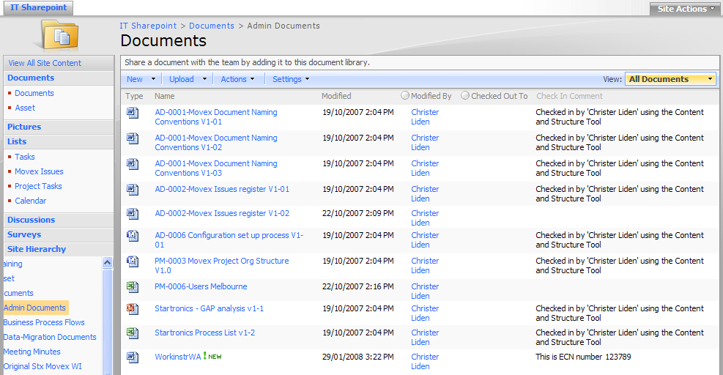

Once the header is created lines can be attached to the header by right click on the header record and select one of the following
- New Item required
- Change to Item required
- Change to BoM required
- Authorizer (who to give the final approval)

Creation of the line record for new item (part or product)

Generally for all the detailed records we will display to the user both the current system value as well as the changed value. This way the user can directly on the screen see the proposed changes

There may be multiple lines for one ECN (there is a one too many relation). The key will be the ECN number and the line number. The ECN number and the line number will be automatically generated and can’t be changed.

A line can be either
    - Created
    - Changed
    - Viewed

The first view would list all the lines attached to the selected ECN. To view, change or delete the user would right click on the line and select the either of the options.

To create a new record the user would click on the icon “Create New”. That would bring the user to a detailed screen where the following information would be entered.

The name of this table will be ZECNITMN and the field prefix would be NI

Field | Description | Logic | Length | Movex field | Resp
Company | Company ID | From the Site def | 3 | CONO
ECN Number |  | This is the ECN number from the header record and may not be changed | 5N | ZECNID
Line number |  | This is a line number for the table that may be change but must be unique for the ECN | 3 N | ZECDLN
New Item Flag | Indicates is the item is a new one or an existing one | 1 = NEW  0 = EXISTING | 1 N | ZNWITF
Item number | The new item number | To be validated that this item doesn’t already exists | 15A | ITNO | Eng
Status | The Item Status | Will list 2 valid options. 10 = preliminary and 20 = Released | 2A | STAT | Eng
Name | The item description | Not to be validated | 30A | ITDS | Eng
Description | This is the long description in Movex |  | 60A | FUDS | Eng
Drawing number | This is the drawing number and will be stored in the same field in Movex | Not to be validated but this application needs to automatically generate the drawing number. So when the ECN is activated the application is generating these records prior to creating the item record | 20A | DWNO | Eng
Item category 1 | We will be using Procurement group in Movex for this field | To be validated against Movex (MITMAS) | 3A | PRGP | Eng
Item category 2 | We will be using Product group in Movex for this field | To be validated against Movex (MITMAS) | 5A | ITCL | Eng
Customer code | This is the item group in Movex | To be validated against Movex (MITMAS) | 8A | ITGR | Eng
Basic UoM | Basic Unit of measure | To be validated against Movex (MITMAS) | 3A | UNMS | Eng
Revision | This is our revision | No Validation | 4N | ECVE | Eng
Movex Item Template | The Item number to be copied as part of the base set up | To be validated against Movex. This is the item that will be used to copy from when the records are created (MITMAS) | 15A | ATPL | Eng
Manufacturer | This is the manufacturer of the part and should be validated against the supplier master file in Movex | To be validated against Movex (MITBAL) | 10A | SUNO | Eng
Planner Code | This is the Responsible Code in Movex and needs to be updated both in MM001 as well as MMS002 | To be validated against Movex (MITMAS) | 10A | RESP (MMRESP, MBRESP) | Log
Buyer | This is the Buyer code in Movex and is also defined as a user within Movex | To be validated against Movex, MITBAL | 10 A | BUYE( MBBUYE) | Log
Purchase Price | This is the estimated purchase price that will form the basis for the std costed price |  | 17.6 N | PUPR (MMPUPR) | Log
Supplier Lead-time | This is the suppliers lead-time |  | 3 N | LEA1 (MBLEA1) | Log
Reorder Point | The reorder point value to be entered into Movex |  | 15 N | REOP (MBREOP) | Log
Order Multiple | This is the multiple factor that the items needs to be purchased in |  | 15 N | UNMU (MBUNMU) | Log
Economical order quantity days | This is the old fixed days supply from Oracle |  | 3 N | EQDA (MBEQDA) | Log
Customers Revision Number | This is the customers revision number | We will use a free field in the Movex item master file for this. With no validation. When we are running the update this value needs to be populated in the underlying table | 10 A | CFI1 (MMCFI1) | Eng
Customers Part number | ?????????????? | We will use an alias number for this |  | File MITPOP | Eng

Each of the fields can be defined as edit, view or not being displayed. The security set up is a configuration issue and not a development issue. The set up above is to be give the Engineering department only access to the engineering fields and the logistics department to have access to the logistics field.

Attached to the part number there may be the manufacturer’s part number. Since there might be a one too many relation the manufacturer’s part number would be displayed in a list. The potential changes to the manufacturer’s part-number would be stored in the following structure.

The name of this table will be ZECNMPNI and the field prefix will be “CM”

This information will be stored in Movex in tables MATVAM, MATVAV and MPDOPT. There will be a number of default values we need to use. AIATID (attribute ID will always be “MPN”

Field | Description | Logic | Length | Movex field | Resp
Company | The Movex company number | AJCONO in MATVAV and AICONO in MATVAM | 3 N | CONO
ECN Number |  | This is the ECN number from the header record and may not be changed | 5N | ZECNID
Line number |  | This is a line number for the table that may be change but must be unique for the ECN | 3 N | ZECDLN
Sequence Number | This is the sequence number | AJANSQ in MATVAV. If the flag is set to change or delete we need to validate that the line already exists. If we need to add then we would like to validate that the lines doesn’t already exists | 4 N | MSEQ
Add/Delete/Change flag | Indicates if the line should be added or deleted or changed | Drop down box  1 = ADD  2 = DELETE  3 = CHANGE | 1N | ZACTFL
Option | This is the key we need in the Movexs file structure. The design is that this will be a combination of the supplier number and an index though this is a free field that the user can enter anything as long as it is unuiqe | AJAALF in MATVAV as well as PFOPTN in MPDOPT | 15 A | OPTN
Manufacturers part number | This is the manufacturer part-number | PFTX30 in MPDOPT | 30A | MFIT | Eng
Manufacturer | The Supplier number for the manufacturer in Movex | To be validated against Movex, AIOBV1 | 10 A | SUNO | Eng
Description | This is the description of the MPN | PFTX30 in MPDOPT | 30 A | TX30
Active Flag | This is a flag that indicates that the MPN is valid to be used | PFXCOC in MPDOPT | BOOLEAN | ZMPNFL
Valid From | This is the valid from date | PFMTCT in MPDOPT | 8 N MovexDate |  | Eng

Throughout the application all fields can be
- Audit trailed – i.e the changed is logged and can be easily view and the user Id of the person that made the changed will be logged.
- Each field can be protected via security set up. I.e only certain users can update certain fields.
- Document’s or links (SharePoint) can be linked to each of the records.

Creation of the line record for change of item (part or product)

Once the header is created lines can be attached to the header by right click on the header record and select one of the following
- New Item required
- Change to Item required
- Change to BoM required
- Authorizer (who to give the final approval)

If the user wants to add a record that will be subject to change of data in Movex the user would first select option “Change to Item”. This will take the user to a list view of all the change records. The first time an ECN is update there will be no records in this view.

There may be multiple lines for one ECN (there is a one too many relation). The key will be the ECN number and the line number.

A line can be either
    - Created
    - Changed
    - Viewed

The first view would list all the lines attached to the selected ECN. To view, change or delete the user would right click on the line and select the either of the options.

To create a new record the user would click on the icon “Create New”. That would bring the user to a detailed screen where only the item number would be entered.

The name of this table will be ZECNITMC. The field prefix will be “CI”

Field | Description | Logic | Length | Movex field | Resp
Company |  | Company from the site def | 3 N | CONO
ECN Number |  | This is the ECN number from the header record and may not be changed | 5 N | ZECNID
Line number |  | This is a line number for the table that may be change but must be unique for the ECN | 3 N | ZECLN
Item number | The item number that is subject to change | To be validated against Movex | 15A | ITNO (MMITNO) | Eng

Once the user confirm the item number this is to be validated against the Movex data and then take the user to a detailed screen where the user can enter the new data that needs to be changed and at the same time be able to display the current data.

Field | Description | Logic | Length | Movex field | Resp
Description | The item description | Not to be validated | 30A | ITDS (MMITDS) | Eng
Long Description | This is the long description in Movex |  | 60A | FUDS (MMFUDS) | Eng
Drawing number | This is the drawing number and will be stored in the same field in Movex | To be validated against Movex | 20A | DWNO (MMDWNO) | Eng
Item category 1 | We will be using Procurement group in Movex for this field | To be validated against Movex | 3A | PRGP (MMPRGP) | Eng
Item category 2 | We will be using Product group in Movex for this field | To be validated against Movex | 5A | ITCL (MMITCL) | Eng
Customer code | This is the item group in Movex | To be validated against Movex | 8A | ITGR (MMITGR) | Eng
Basic UoM | Basic Unit of measure | Can’t be changed | 3A | UNMS (MMUNMS) | Eng
Revision | This is our revision | Not to be validated against Movex but created in Movex | 4N | ECVE (MMECVE) | Eng
Manufacturer | This is the manufacturer of the part and should be validated against the supplier master file in Movex | To be validated against Movex | 10A | SUNO (MBSUNO) | Eng
Planner Code | This is the Responsible Code in Movex and needs to be updated both in MM001 as well as MMS002 | To be validated against Movex | 10A | RESP (MMRESP, MBRESP) | Log
Buyer | This is the Buyer code in Movex and is also defined as a user within Movex | To be validated against Movex | 10 A | BUYE (MBBUYE) | Log
Purchase Price | This is the estimated purchase price that will form the basis for the std cost price |  | 17.6 N | PUPR (MMPUPR) | Log
Supplier lead-time | This is the suppliers lead-time |  | 3 N | LEA1 (MBLEA1) | Log
Reorder Point | The reorder point value to be entered into Movex |  | 15 N | REOP (MBREOP) | Log
Order Multiple | This is the multiple factor that the items needs to be purchased in |  | 15 N | UNMU (MBUNMU) | Log
Economical order quantity days | This is the old fixed days supply from Oracle |  | 3 N | EQDA (MBEQDA) | Log
Customers Revision Number | This is the customers revision number | We will use a free field in the Movex item master file for this. With no validation. When we are running the update this value needs to be populated in the underlying table | 10 A | CFI1 (MMCFI1) | Eng

Attached to the part number there may be the manufacturer’s part number. Since there might be a one too many relation the manufacturer’s part number would be displayed in a list. The potential changes to the manufacturer’s part-number would be stored in the following structure.

The name of this table will be ZECNMPNI

This information will be stored in Movex in tables MATVAM, MATVAV and MPDOPT. There will be a number of default values we need to use. AIATID (attribute ID will always be “MPN”

Field | Description | Logic | Length | Movex field | Resp
Company | The Movex company number | AJCONO in MATVAV and AICONO in MATVAM | 3 N
Add/Delete/Change flag | Indicates if the line should be added or deleted or changed | Drop down box | 1N
Item number | The part-number | AIOBV2 in MATVAM | 15 A
Sequence Number | This is the sequence number | AJANSQ in MATVAV. If the flag is set to change or delete we need to validate that the line already exists. If we need to add then we would like to validate that the lines doesn’t already exists
Manufacturers part number | This is the manufacturer part-number | AJAALF in MATVAV | 30A |  | Eng
Manufacturer | The Supplier number for the manufacturer in Movex | To be validated against Movex, AIOBV1 | 10 A | SUNO | Eng
Description | This is the description of the MPN | PFTX30 in MPDOPT
Active Flag | This is a flag that indicates that the MPN is valid to be used | PFXCOC in MPDOPT
Valid From | This is the valid from date | PFMTCT in MPDOPT | 10 N |  | Eng

Each of the fields can be defined as edit, view or not being displayed. The security set up is a configuration issue and not a development issue. The set up above is to be give the Engineering department only access to the engineering fields and the logistics department to have access to the logistics field.

Creation of the line record for change or create a BoM

Once the header is created lines can be attached to the header by right click on the header record and select one of the following
- New Item required
- Change to Item required
- Change to BoM required
- Authorizer (who to give the final approval)

If the user wants to add a record that will be subject to change of data in Movex the used would first select option “Change / Create BoM”. This will take the user to a list view of all the change records. The first time an ECN is update there will be no records in this view.

There may be multiple lines for one ECN (there is a one too many relation). The key will be the ECN number and the line number.

A line can be either
    - Created
    - Changed
    - Deleted
    - Viewed

The first view would list all the lines attached to the selected ECN. To view, change or delete the user would right click on the line and select the either of the options.

To create a new record the user would click on the icon “Create New”. That would bring the user to a detailed screen where only the product number and the sequence number would be entered.

The name of this table will be ZECNBOMS. The field prefix will be “BM”

Field | Description | Logic | Length | Movex field | Resp
Company | Company | From the site def | 3 N | CONO
ECN Number |  | This is the ECN number from the header record and may not be changed | 5 N | ZECNID
Line number |  | This is a line number for the table that may be change but must be unique for the ECN | 3 N | ZECNLN
Create New or change existing BoM | This is a flag to indicate if we should be creating a new record or change an existing one | This would be a ticked = New and not ticked = Change | 1 N
Product number | The Product number that is subject to change | To be validated against Movex if the previous flag is not ticked (change) but if the field above is ticked we need to validate this against the table ZECNITMN | 15A | PRNO(MMITNO) | Eng
Structure Type | This is the structure type |  | 3A | STRT
Sequence number | This is the sequence number in Movex | To be validated against Movex and give a warning if the record doesn’t exist???????? | 4N | MSEQ( PMMSEQ) | Eng

Once the user confirm the product number and the sequence number the user gets to a detailed screen where the user can enter the new data that needs to be changed and at the same time be able to display the current data should this exist.

Field | Description | Logic | Length | Movex field | Resp
Add/Delete/Change flag | Indicates if the line should be added or deleted or changed | Drop down box  1 = ADD  2 = DELETE  3 = CHANGE | 1N | ZACTFL
Sequence number | This is the sequence number in Movex | To be validated against Movex if we are changing or deleting a record. If we are adding a record we must make sure the record doesn’t already exists. | 4N | PMMSEQ | Eng
Operations number | This is the sequence number in Movex | To be validated against Movex. | 4N | OPNO | Eng
Effective date | This is the date when the change is to be implemented |  | 8 N | FDAT | Eng
Part Number | This is the new part number that either needs to be changed or added | To be validated against Movex if we are changing or adding a record. We would validate this against MITMAS. If no hit we would validate against ZECNITMC and display the message “pending ECN”. If not hit in neither of these tables then we would not accept the record | 15 A | MTNO | Eng
Qty | This is the new Qty |  | 15,6 N | ZNWQTY | Eng
Circuit Reference Number | This is the position on the board | This will be stored in a separate table. We could potentially look at comparing the two fields and display the difference in a separate field but this is something I would like to move to past go live | TEXT CLOB 200 | ZCIRRF Text Field 200 pos | Eng
BOM Notes | This is just a free text not to be stored in Movex |  | Text clob | ZBOMNT | Eng

Each of the fields can be defined as edit, view or not being displayed. The security set up is a configuration issue and not a development issue. The set up above is to be give the Engineering department only access to the engineering fields and the logistics department to have access to the logistics field.

The circuit references will be stored in a separate table ZECNCIRF. The field prefix will be “CR”

Field | Description | Logic | Length | Movex field | Resp
Company |  | Company | 3N | CONO
Structure Type | This is the structure type in Movex | Validated against Movex | 3A | STRT
Product number | The Product number that is subject to change | To be validated against Movex | 15A | ITNO (MMITNO) | Eng
Sequence number | This is the sequence number in Movex | To be validated against Movex | 4N | MSEQ (PMMSEQ) | Eng
Circuit Reference Number | This is the position on the board | Text field | TEXT CLOB 200 | Text field 200 pos | Eng

Creation of the line record for authorizers of ECN

The last basic data that needs to be added is the users that are to final approve the ECN. There will be 4 different roles and for each role a specific user will be added. These are the users that will, as part of the workflow be assigned the task to authorize or to be notified of the ECN.

Once the header is created authorizer can be attached to the header by right click on the ECN record and select add authorizers.

There may be multiple lines for one ECN (there is a one too many relation). The key will be the ECN number and the line number.

A line can be either
    - Created
    - Changed
    - Viewed

The first view would list all the lines attached to the selected ECN. To view, change or delete the user would right click on the line and select the either of the options.

To create a new record the user would click on the icon “Create New”. That would bring the user to a detailed screen where the details may be entered.

The table for ECN Authorizer is ZECNAUTH. The field prefix will be “AU”

Field | Description | Logic | Length | Movex field | Resp
Company | Company | Company | 3N | CONO
ECN Number |  | This is the ECN number from the header record and may not be changed | 5 N | ZECNID
User ID | This is the user ID for the person that is to authorize the ECN | To be validated against Movex | 10A | RESP | Eng
Department | This indicates the department the person authorizes for. There may be only one person for each department. | There will be 4 fixed values to pick from  "Logistics"  "Engineering"  "Procurement"  "Finance" | 12 A | ZECNDP | Eng
Type | This indicates if this person is an authorizer or if the person should be receiving notifications | There will be 2 fixed values to pick from  “Authorize”  “Notified” | 12 A | ZENCUT | Eng

Each of the fields can be defined as edit, view or not being displayed. The security set up is a configuration issue and not a development issue. The set up above is to be give the Engineering department only access to the engineering fields and the logistics department to have access to the logistics field.

Work flow
In order to execute the ECN a workflow will support the process. Below is a diagram that describes the workflow in principle.

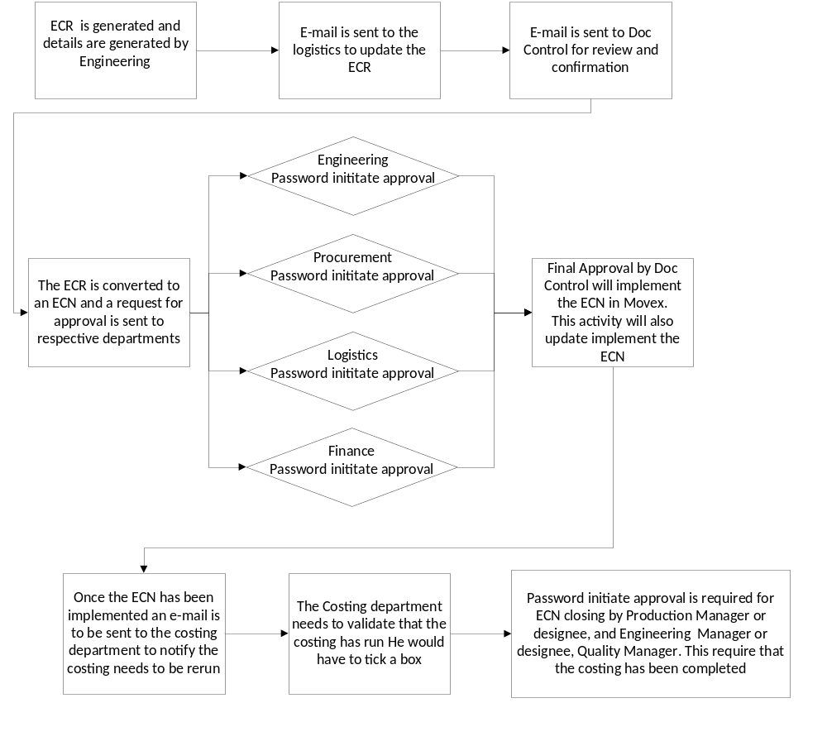

The workflow is a configure solution and will cover aspects such as

- The workflow will be initiated by the creation of a ECN
- E-mail or SMS or work-list will be used to notify users that a task is requiring action.
- At any time can authorised users view the status and progress of the ECN. This is done both graphically and via list views
- A task that has been assigned to a specific user can during the course of the ECN be changed to a different user
- The workflow can be design to cater for escalation should a task not be completed within a set time frame.
- There is no limit to the number of processes that can be run at the same time.
- E-form to be used as a response is possible but requires some additional configuration. This is not included in this specification.
- The entire application is web based and this way it can be accessed from anywhere. In other words this may be accessed by customers as well as internal users.
- As aspects of this application can be security defined down to a field level
- The password initiated approval means that only a specific user can approve the ECN and this needs to be done by entering a password. This information is also stored for audit purpose once the ECN has been approved.

ComActivity Project Team
The ComActivity team selected for your project includes the following consultants:
- Christer Liden – Project Manager/Business Consultant
- Torben Magnusson – Quality Control
- Miguel Arroyo – Business Consultant/Technical

System Requirements
The following server and software configurations will support up to 150 concurrent users:

- IBM e-Server 336 x64-based system with 2 Intel Xeon EMT 64 processors (or equivalent) and a minimum of 6GB RAM.
- Microsoft Windows Server 2003 64 – Bit Standard Edition. (Note: the x64 architecture support up to 32 GB of RAM)
- Either IBM Websphere Portal or Apache Jetspeed Portal
- Either IBM Websphere Application Server or Apache Tomcat Application Server
- Any major relational database. Eg. Oracle, DB2, MySQL, MS SQL Server.

**Note: We have recommended MS Windows server but ComActivity will also run on Linux.

